User Guide - Arch LOG8430

Welcome to this user guide, designed to teach you how our software is built and how to use it.

Disclaimer: Everything was written as if the user was a man. Don’t be upset if you see *his* or *him* it is just easier to have only one gender. In advance, apologies ladies.

# Arch LOG8430 – What for?

First of all, this software is designed with Java. Because of it, you need to have the latest version of Java installed on your computer before using our software. **Java 8 is needed.**

The purpose of this software is to allow a user to centralize his streaming music services in one app, to allow him to listen to his playlist, modify them and even create new playlist. Next feature (but not implemented yet) would be to have a playlist with more than one service provider in it. For now, it is only possible to play one playlist for one service provider.

This software allows also to browse between the providers, select songs to play and even create a playlist from song in the search results.

# The first look

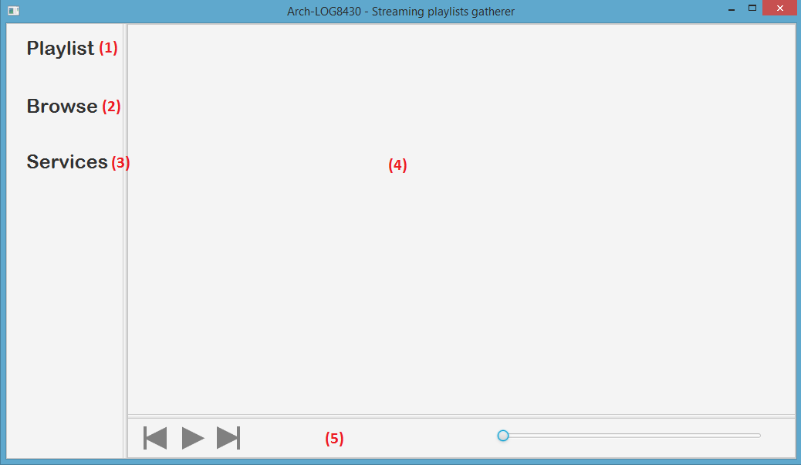

1. Playlist: This menu brings the user to the selection of all his playlists. The user needs to be authenticated to all the services he wants to use in order to see his playlists and create them. (See the … section)
2. Browse: This menus brings the user to the search engine.
3. Services: Allows the user to authenticate himself to all the services supported by the software.
4. Module Pane: The three options before will show in this space.
5. Player: This is the controller of the player. Where the song will be played. (See the … section for more information)

# Playlists Overview

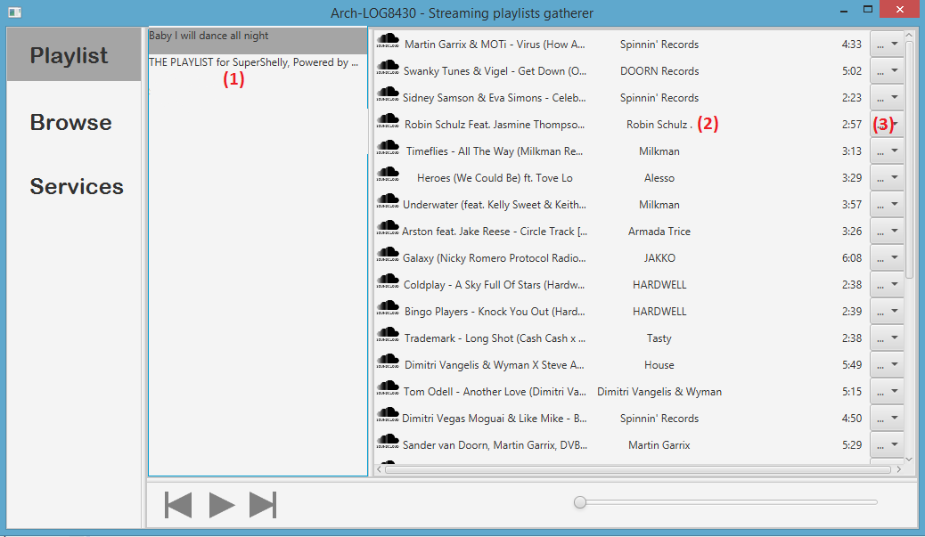

1. Playlist list: All of the user’s playlists from the authenticated services will be displayed here. Left click on one will display all the songs in the song pane
2. Song Pane: All the songs in the playlist will be displayed here. There is :
   * Logo of the service (Soundcloud here)
   * The title of the song
   * The singer/artist
   * The album (Not provided with Soundcloud)
   * The duration of the song
   * Set of actions (cf. next point)

Double-click on the song will play it. All the playlist will be played, the next song will be played after the first is over.

1. 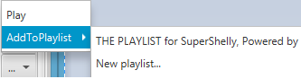Actions:
   * Play : Same as double click
   * Add to playlist: Add this song  
     to another playlist already  
     created. Or create a new one.

# Browse Overview

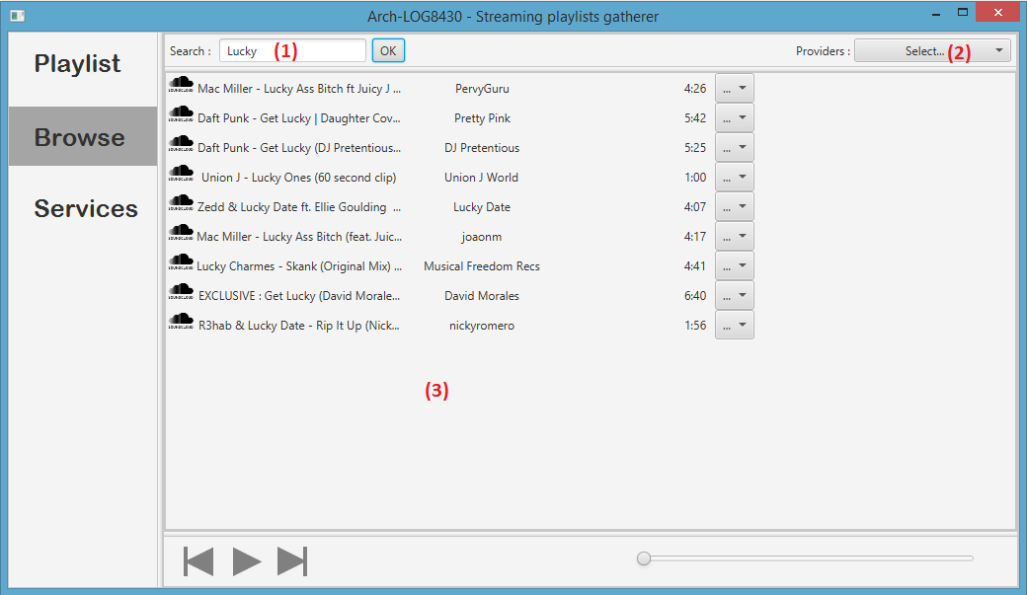

1. Search area: Let the user to search song with one keyword. Click on OK to run the search.
2. Providers: Select all the providers the search engine will look into. By default, everything is selected, but the user can filter the answer with this.
3. Song Pane: Cf. section 2.2 (same as playlists)

# Services authentication Overview

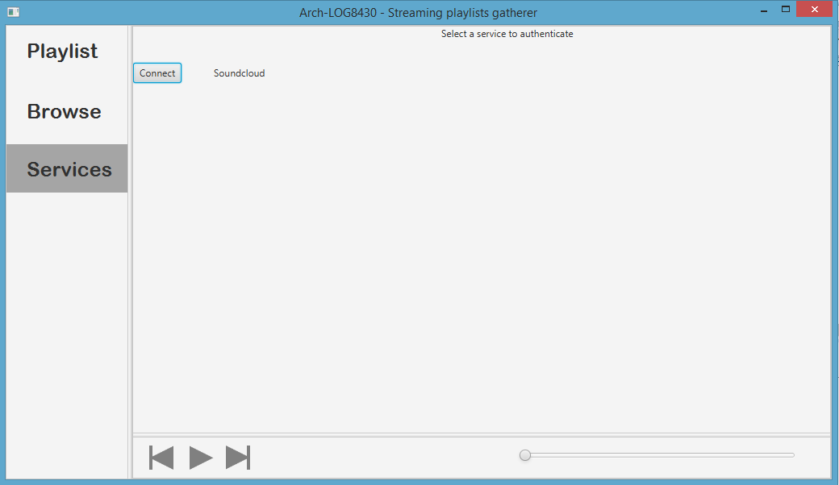

The service overview is easy. It lists all the services. If the user is not connected, you can click on Connect and a popup will him authenticate. When it’s done, or if the user is already connected he can disconnect. (The button is green to tell the user he is connected)

# The player



1. Previous: Change to the song just before this one in the playlist. Impossible if it is the first song of the playlist.
2. Play/Pause : Play and pause the song
3. Next: Change to the song just after this one in the playlist. Impossible if it is the last song of the playlist.
4. Title of the song
5. Time elapsed
6. Slider: Indicate the current position in the song. Cannot seek yet.
7. Total Duration